#include<stdio.h>  
int acc();  
int withdrawal();  
int deposit(int n);  
int main()  
{  
    int tot;  
    acc();  
    printf("Enter amount\n");  
    scanf("%d",&tot);  
  
    tot= withdrawal(tot);  
  
    deposite(tot);  
    return(0);  
}  
 acc()  
 {  
  char name[10];  
  int num,tot;  
  printf("Enter name\n");  
  scanf("%s",name);  
  printf("Enter account number\n");  
  scanf("%d",&num);  
 }  
 int withdrawal(int n)  
 {  
  int amt,new_tot;  
  printf("Enter amount to be withdrawed\n");  
  scanf("%d",&amt);  
  new_tot = n - amt;  
  printf("Remaining balance= %d\n",new_tot);  
  return(new_tot);  
  
}  
int deposite(int n)  
{  
    int a;  
    printf("Enter amount to be deposited\n");  
    scanf("%d",&a);  
    n=n+a;  
    printf("Balance=%d\n",n);  
  
}

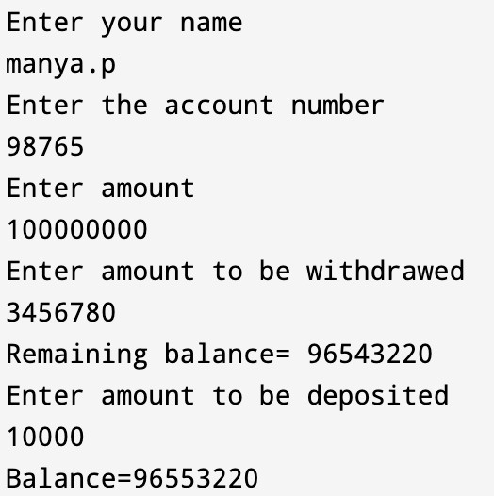

2. #include <stdio.h>  
#include <string.h>  
int main() {  
char str[5][50], temp[50];  
printf("Enter 5 words: ");  
for (int i = 0; i < 5; ++i) {  
fgets(str[i], sizeof(str[i]), stdin);  
}  
for (int i = 0; i < 5; ++i) {  
for (int j = i + 1; j < 5; ++j) {  
if (strcmp(str[i], str[j]) > 0) {  
strcpy(temp, str[i]);  
strcpy(str[i], str[j]);  
strcpy(str[j], temp);  
}  
}  
}  
printf("\nIn the lexicographical order: \n");  
for (int i = 0; i < 5; ++i) {  
fputs(str[i], stdout);  
}  
return 0;  
}

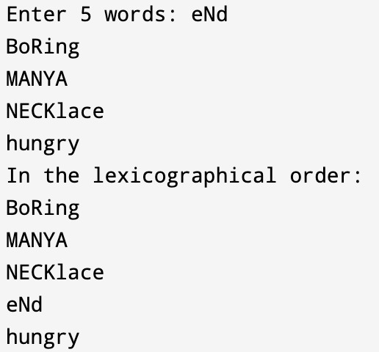

3. #include <stdio.h>  
main()  
{  
int arr[10], num, i, n, pos = -1;  
printf("\n Enter the number of elements in the array : ");  
scanf("%d", &n);  
printf("\n Enter the elements :");  
for(i=0;i<n;i++)  
scanf("%d", &arr[i]);  
printf("\n Enter the number that has to be searched : ");  
scanf("%d", &num);  
for(i=0;i<n;i++)  
{  
if(arr[i] == num)  
{  
pos=i+1;  
printf("\n %d is found in the array at position = %d", num, pos);  
break;  
}  
}  
if (pos== -1)  
printf("\n %d DOES NOT EXIST in the array", num);  
return 0;  
}

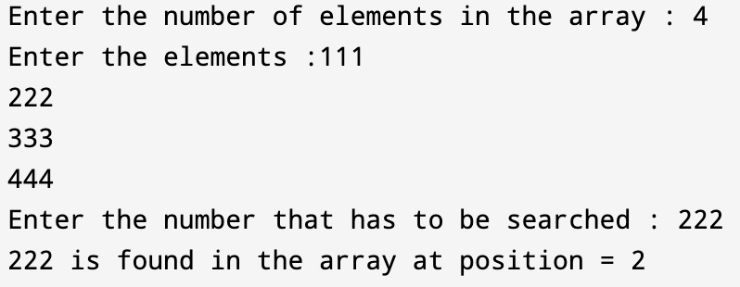

4. #include <stdio.h>  
#include <string.h>  
int main()  
{  
char str[] = "Happy go lucky personality";  
char search[] = "lucky";  
char *ptr = strstr(str, search);  
if (ptr != NULL)  
{  
printf("'%s' contains '%s'\n", str, search);  
}  
else  
{  
printf("'%s' doesn't contain '%s'\n", str, search);  
}  
return 0;  
}

C:\Users\Pramila\AppData\Local\Temp\Rar$DIa0.936\PHOTO-2023-12-20-21-15-56.jpg

5. #include <stdio.h>

int lastIndex(int arr[], int size, int target) {

int lastIndex = -1; // Initialize the variable to store the last index

for (int i = 0; i < size; i++) {

if (arr[i] == target) {

lastIndex = i; // Update the last index when the target is found

}

}

return lastIndex;

}

int main() {

int size, target;

printf("Enter the size of the array: ");

scanf("%d", &size);

int arr[size];

printf("Enter the array elements:\n");

for (int i = 0; i < size; i++) {

scanf("%d", &arr[i]);

}

printf("Enter the number to find the last occurrence: ");

scanf("%d", &target);

int result = lastIndex(arr, size, target);

if (result != -1) {

printf("The last occurrence of %d is at index %d.\n", target, result);

} else {

printf("The number %d is not found in the array.\n", target);

}

return 0;

}

Output:

Enter the size of the array: 5  
Enter the elements of the array:  
Element 1: 4  
Element 2: 7  
Element 3: 2  
Element 4: 7  
Element 5: 9  
Enter the number to find the last occurrence: 7  
The last occurrence of 7 is at index 3

6. #include <stdio.h>  
main()  
{  
int arr[10], num, i, n, pos = -1;  
printf("\n Enter the number of elements in the array : ");  
scanf("%d", &n);  
printf("\n Enter the elements :");  
for(i=0;i<n;i++)  
scanf("%d", &arr[i]);  
printf("\n Enter the number that has to be searched : ");  
scanf("%d", &num);  
for(i=0;i<n;i++)  
{  
if(arr[i] == num)  
{  
pos=i+1;  
printf("\n %d is found in the array at position = %d", num, pos);  
break;  
}  
}  
if (pos== -1)  
printf("\n %d DOES NOT EXIST in the array", num);  
return 0;  
}

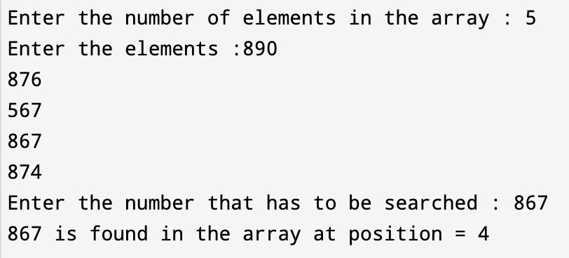

7. #include <stdio.h>  
main()  
{  
int arr[10], num, i, n, pos = -1, beg, end, mid,  
found =0;  
printf("\n Enter the number of elements in the array: ");  
scanf("%d", &n);  
printf("\n Enter the elements: ");  
for(i=0;i<n;i++)  
{  
scanf("%d", &arr[i]);  
}  
printf("\n Enter the number that has to be searched: ");  
scanf("%d", &num);  
beg = 0, end = n-1;  
while(beg <= end)  
{ mid = (beg + end)/2;  
if (arr[mid] == num)  
{  
printf("\n %d is present in the array at position = %d", num, mid+1);  
found=1;  
break;  
}  
if (arr[mid]>num)  
end = mid-1;  
else  
beg = mid+1;  
}  
if (found == 0)  
printf("\n %d DOES NOT EXIST IN THE ARRAY", num);  
return 0;  
}

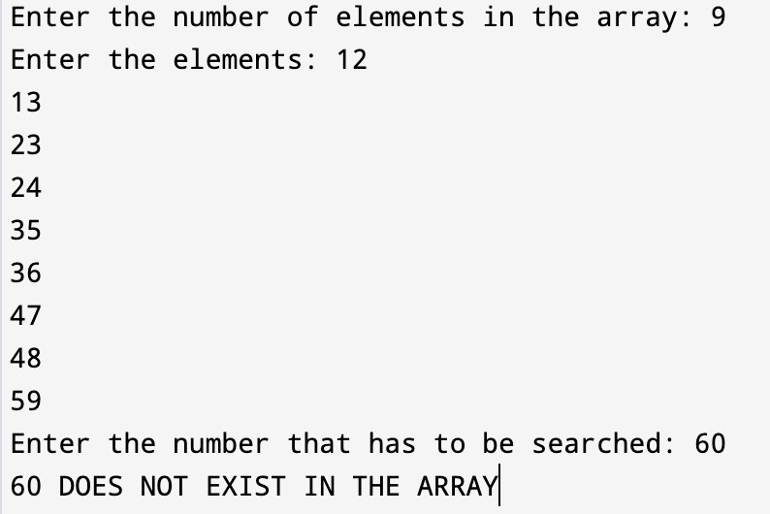

8.

#include<stdio.h>  
  
#define MAX_SIZE 100  
int main()  
{  
int arr[MAX_SIZE];  
int i, max, min, size;  
printf("Enter size of the array: ");  
scanf("%d", &size);  
printf("Enter elements in the array: ");  
for(i=0; i<size; i++)  
{  
scanf("%d", &arr[i]);  
}  
max = arr[0];  
min = arr[0];  
for(i=1; i<size; i++)  
{  
if(arr[i] > max)  
{  
max = arr[i];  
}  
if(arr[i] < min)  
{  
min = arr[i];  
}  
}  
printf("Maximum element = %d\n", max);  
printf("Minimum element = %d", min);  
return 0;  
}

